Docker Challenge

- Create a customized Docker image using a Dockerfile.
Push the image to Docker Hub.
Push the same image to Amazon ECR.

1️⃣ Create a Customized Docker Image

Example project structure

myapp/
├── app.py
└── Dockerfile
- Create Directory < myapp >

mkdir myapp
cd myapp
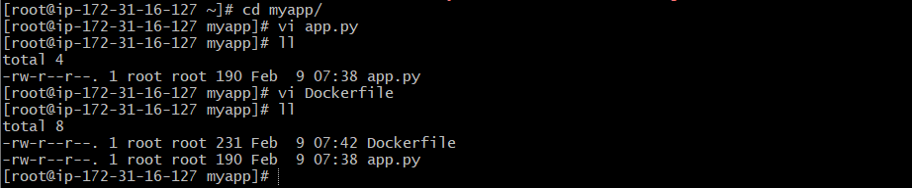
app.py

from flask import Flask

app = Flask(__name__)

@app.route("/")
def hello():
return "Hello from custom Docker image!"

if __name__ == "__main__":
app.run(host="0.0.0.0", port=5000)

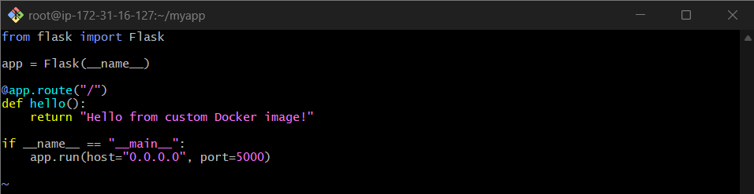

- Create Dockerfile
Vi Dockerfile

Dockerfile

# Base image
FROM python:3.11-slim

# Set working directory
WORKDIR /app

# Install dependencies
RUN pip install flask

# Copy application files
COPY app.py .

# Expose port
EXPOSE 5000

# Run application
CMD ["python", "app.py"]

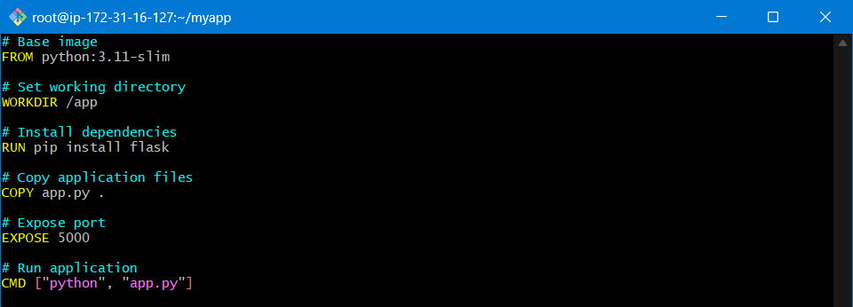

Build the Docker image
docker build -t my-custom-app:1.0 .

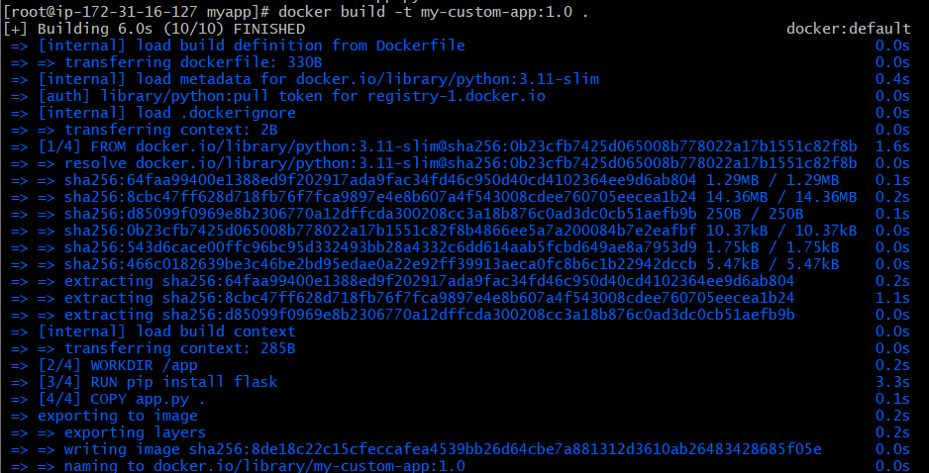

Verify:
docker images

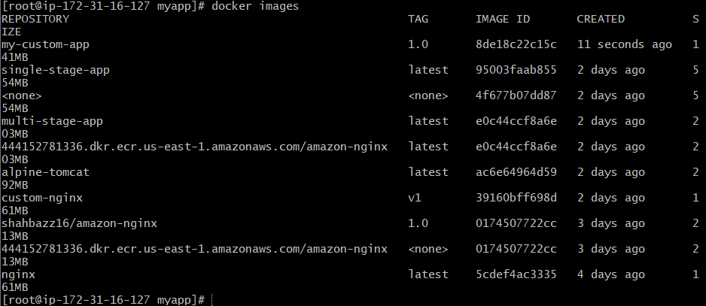

2️⃣ Push Image to Docker Hub

Step 1: Login to Docker Hub
docker login

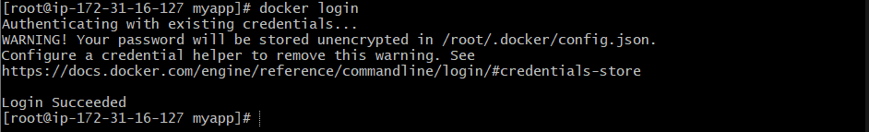

Step 2: Tag the image
Docker Hub format:
docker tag my-custom-app:1.0 shahbazz16/my-custom-app:1.0

Step 3: Push the image
docker push shahbazz16/my-custom-app:1.0

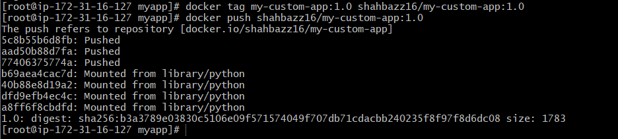

✅ Image is now available on Docker Hub

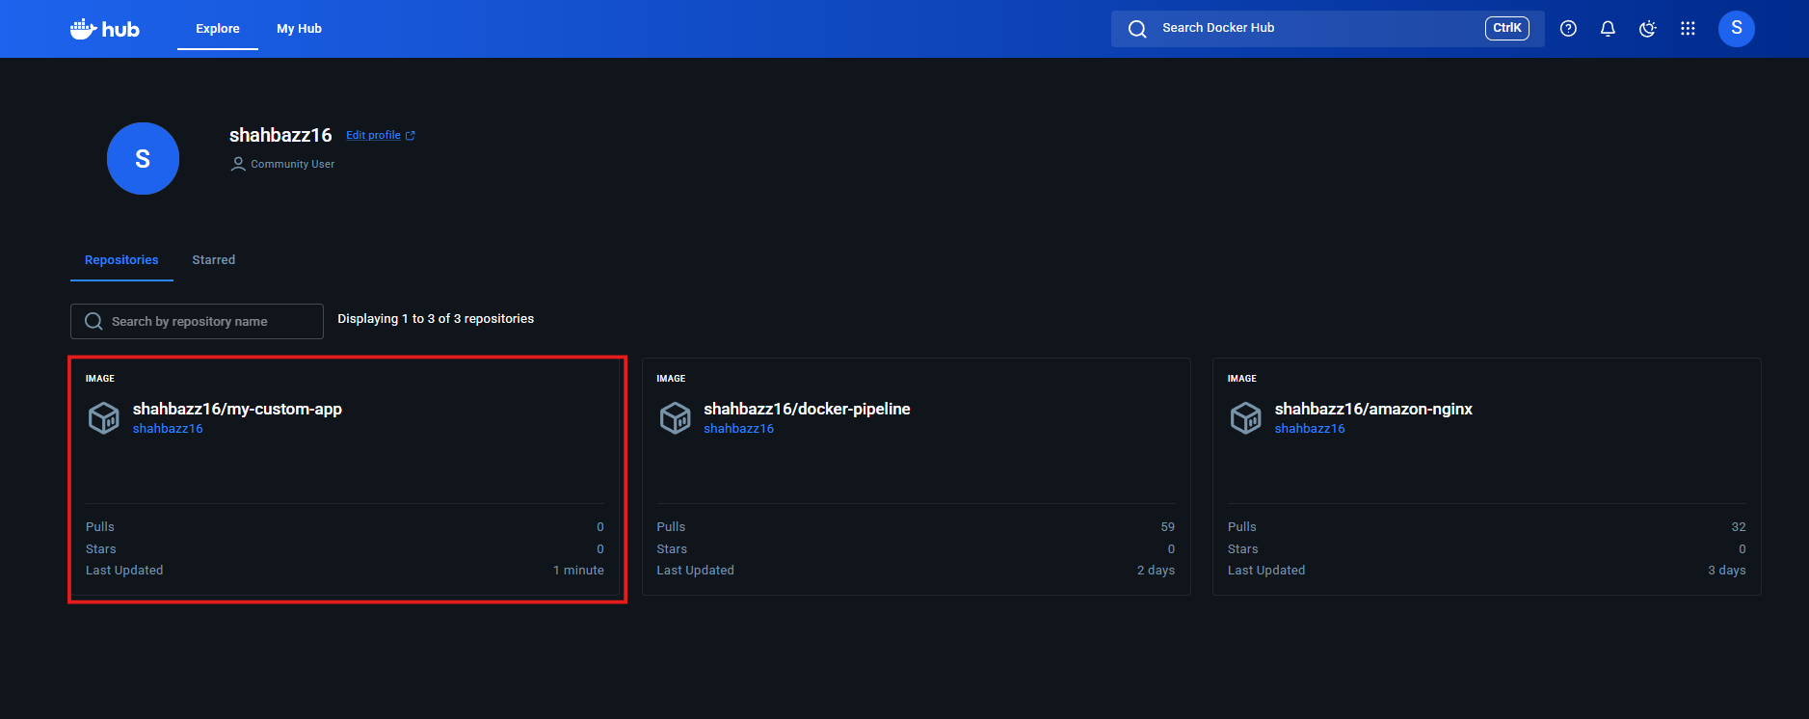
Validation: with tag

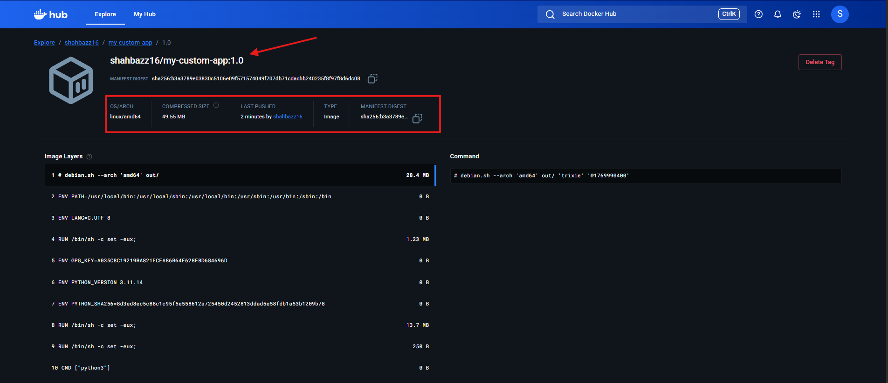

3️⃣ Push the Same Image to Amazon ECR

Prerequisites
- AWS account
- AWS CLI configured:
aws configure

Step 1: Create an ECR repository
aws ecr create-repository \
--repository-name my-custom-app \
--region us-east-1

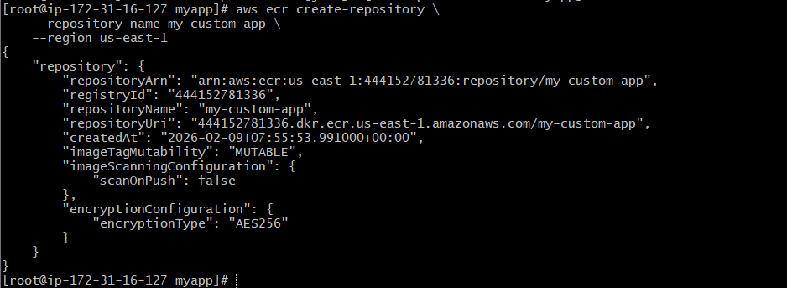

Validation:
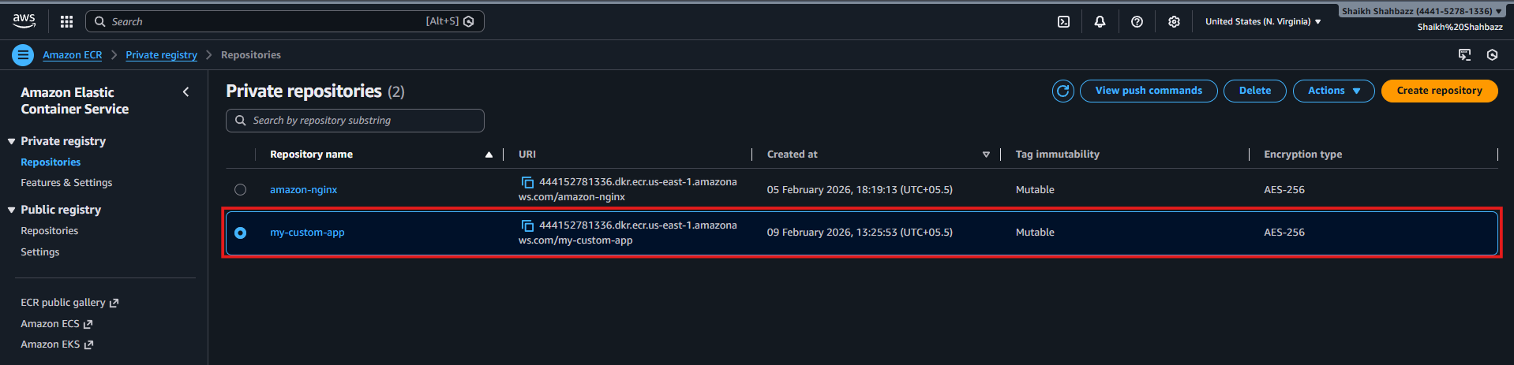

Step 2: Login to Amazon ECR
aws ecr get-login-password --region us-east-1 \
| docker login --username AWS \
--password-stdin 444152781336.dkr.ecr.us-east-1.amazonaws.com

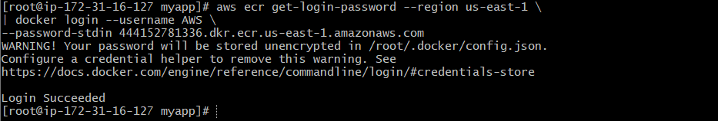

Step 3: Tag the image for ECR
docker tag my-custom-app:1.0 \
444152781336.dkr.ecr.us-east-1.amazonaws.com/my-custom-app:1.0

Step 4: Push to ECR
docker push 444152781336.dkr.ecr.us-east-1.amazonaws.com/my-custom-app:1.0

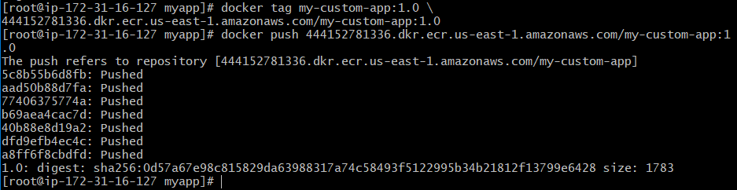

✅ Image is now stored in Amazon ECR

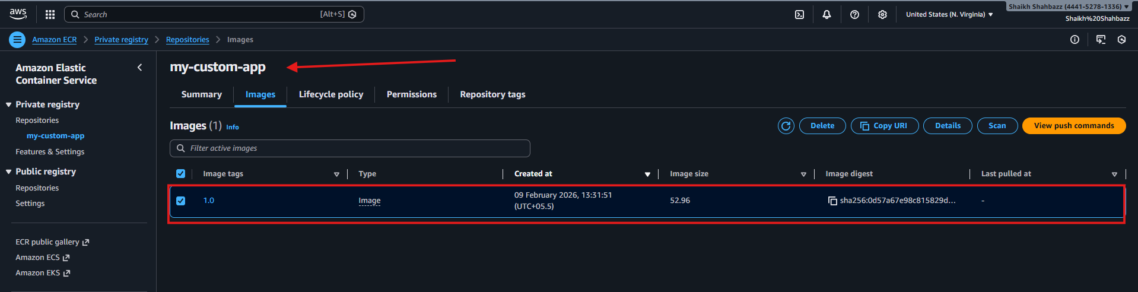

Summary Flow

Dockerfile
↓
docker build
↓
docker tag
├── docker push (Docker Hub)
└── docker push (Amazon ECR)

- Provision one EC2 instance using Terraform and install Jenkins.
Create one Jenkins job to build and push the Docker image to Docker Hub.

✅ PART 1: Provision EC2 Using Terraform & Install Jenkins

1️⃣ Folder Structure

mkdir terraform-jenkins
cd terraform-jenkins

2️⃣ Terraform Configuration (main.tf)

This provisions one EC2 instance and installs Jenkins + Docker automatically.

provider "aws" {
region = "us-east-1"
}

resource "aws_security_group" "jenkins_sg" {
name = "jenkins-sg"

ingress {
from_port = 22
to_port = 22
protocol = "tcp"
cidr_blocks = ["0.0.0.0/0"]
}

ingress {
from_port = 8080
to_port = 8080
protocol = "tcp"
cidr_blocks = ["0.0.0.0/0"]
}

egress {
from_port = 0
to_port = 0
protocol = "-1"
cidr_blocks = ["0.0.0.0/0"]
}
}

resource "aws_instance" "jenkins" {
ami = "ami-0f5ee92e2d63afc18" # Ubuntu 22.04 (us-east-1)
instance_type = "t2.micro"

vpc_security_group_ids = [aws_security_group.jenkins_sg.id]

user_data = <<-EOF
#!/bin/bash
apt update -y
apt install openjdk-17-jdk -y

curl -fsSL https://pkg.jenkins.io/debian-stable/jenkins.io-2023.key | tee \
/usr/share/keyrings/jenkins-keyring.asc > /dev/null

echo deb [signed-by=/usr/share/keyrings/jenkins-keyring.asc] \
https://pkg.jenkins.io/debian-stable binary/ | tee \
/etc/apt/sources.list.d/jenkins.list > /dev/null

apt update -y
apt install jenkins -y
systemctl start jenkins
systemctl enable jenkins

apt install docker.io -y
systemctl start docker
systemctl enable docker

usermod -aG docker ubuntu
usermod -aG docker jenkins
systemctl restart jenkins
EOF

tags = {
Name = "Jenkins-Server"
}
}

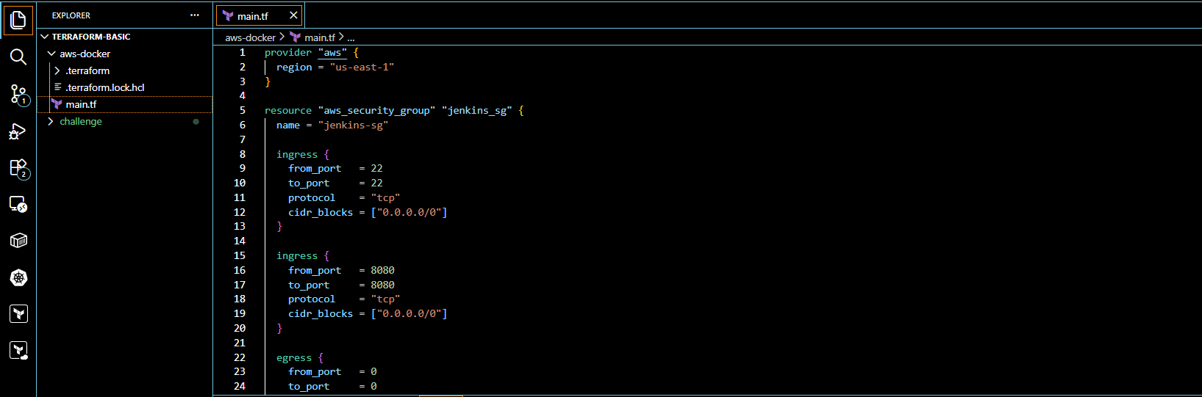

3️⃣ Run Terraform
terraform init

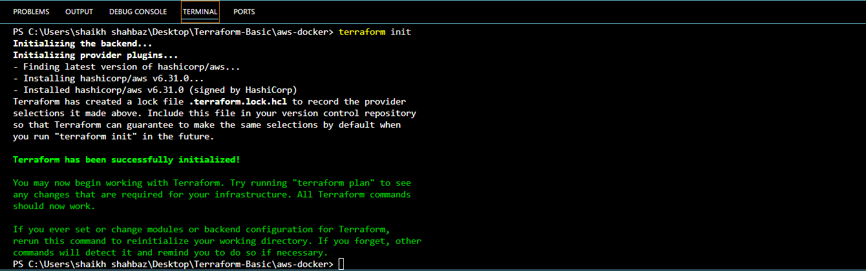

terraform validate

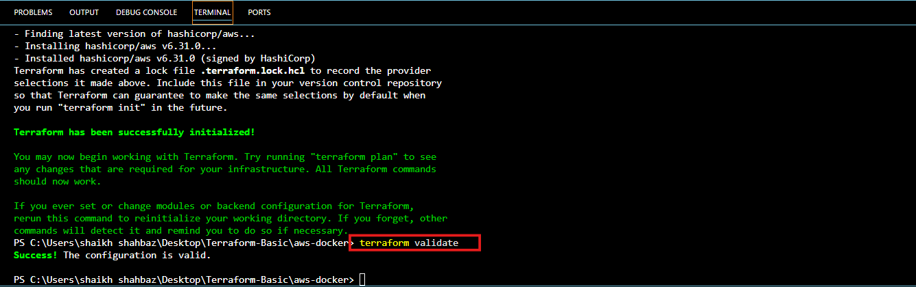

terraform plan

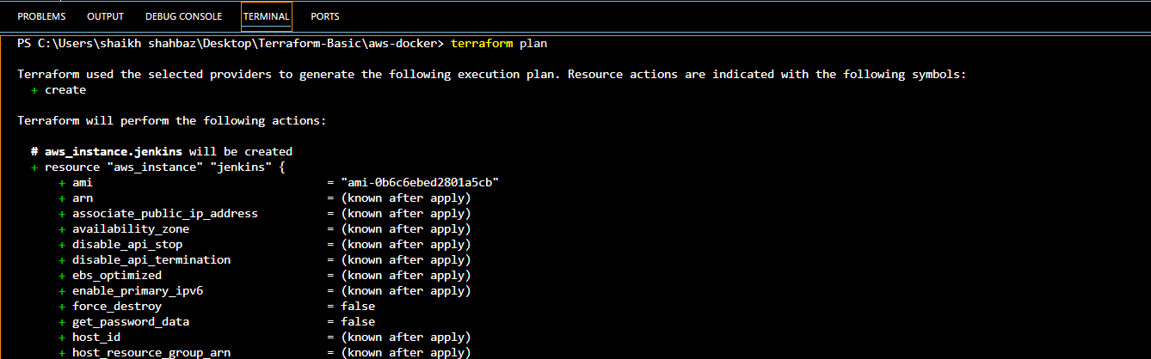

terraform apply -auto-approve

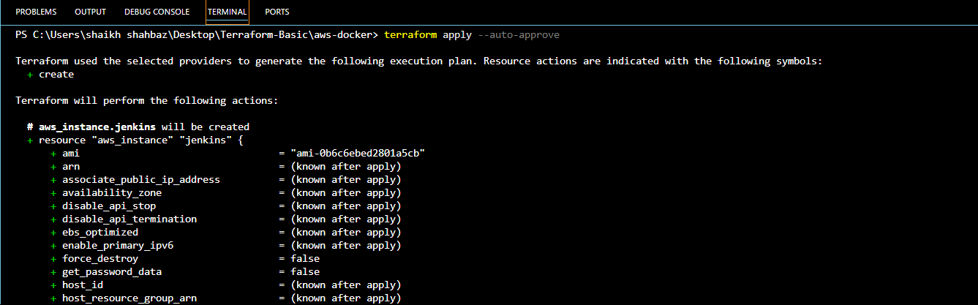
Validation: Check your aws account one instance will get launched with name < Jenkins-server >

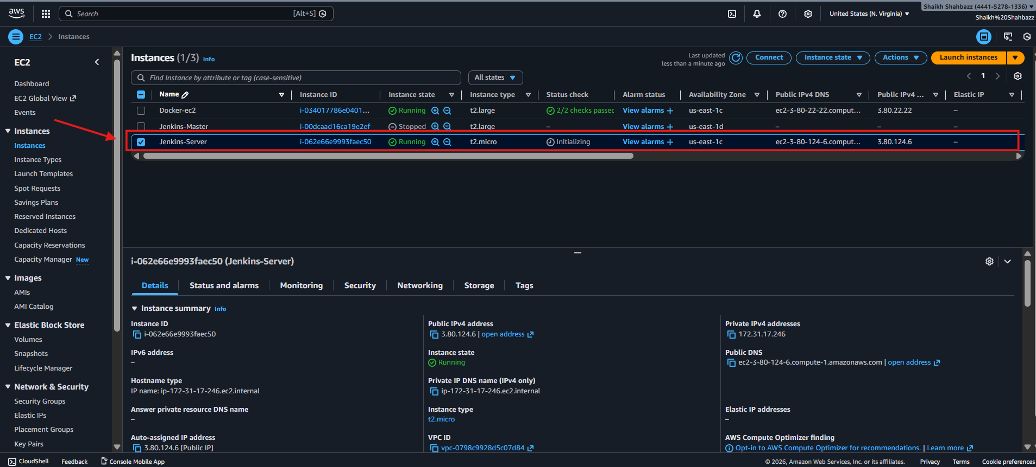

4️⃣ Access Jenkins

http://<EC2_PUBLIC_IP>:8080

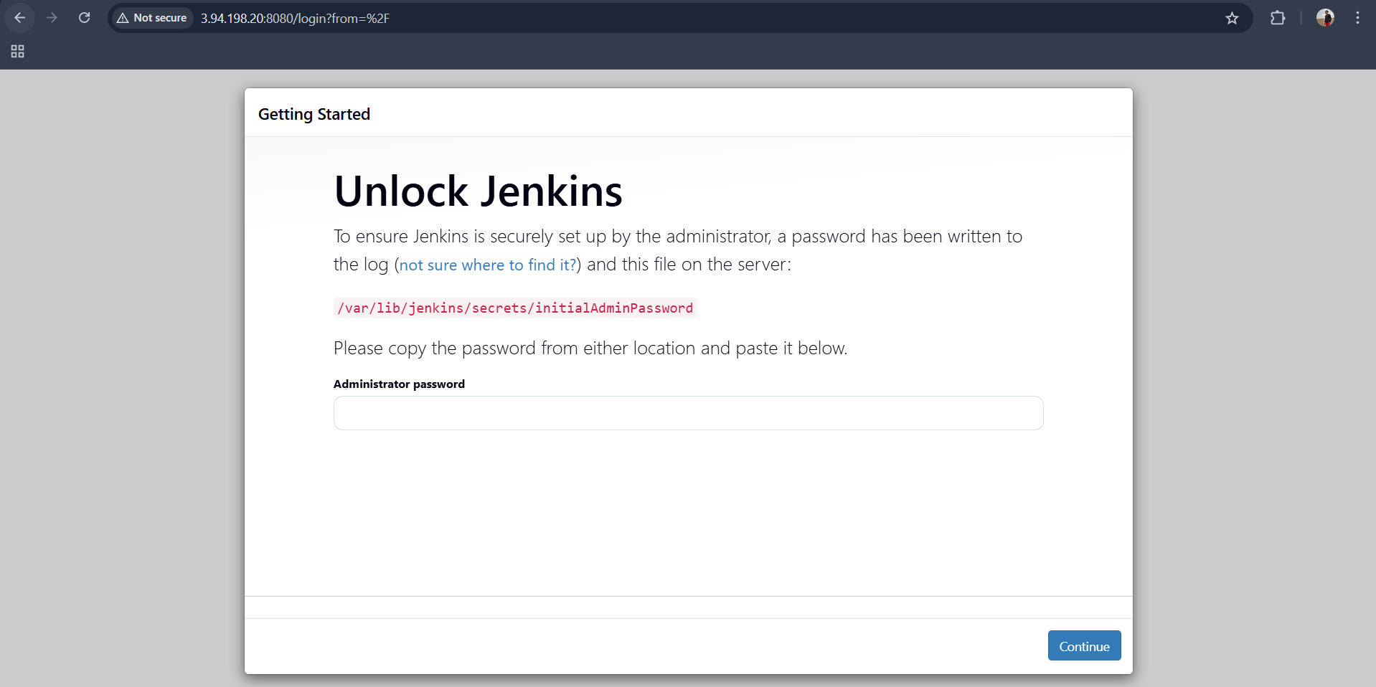

Get initial password:

sudo cat /var/lib/jenkins/secrets/initialAdminPassword

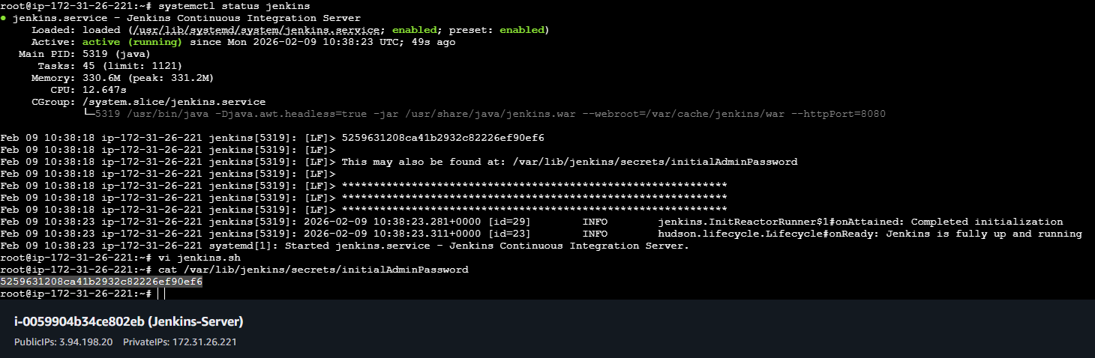
Validation:
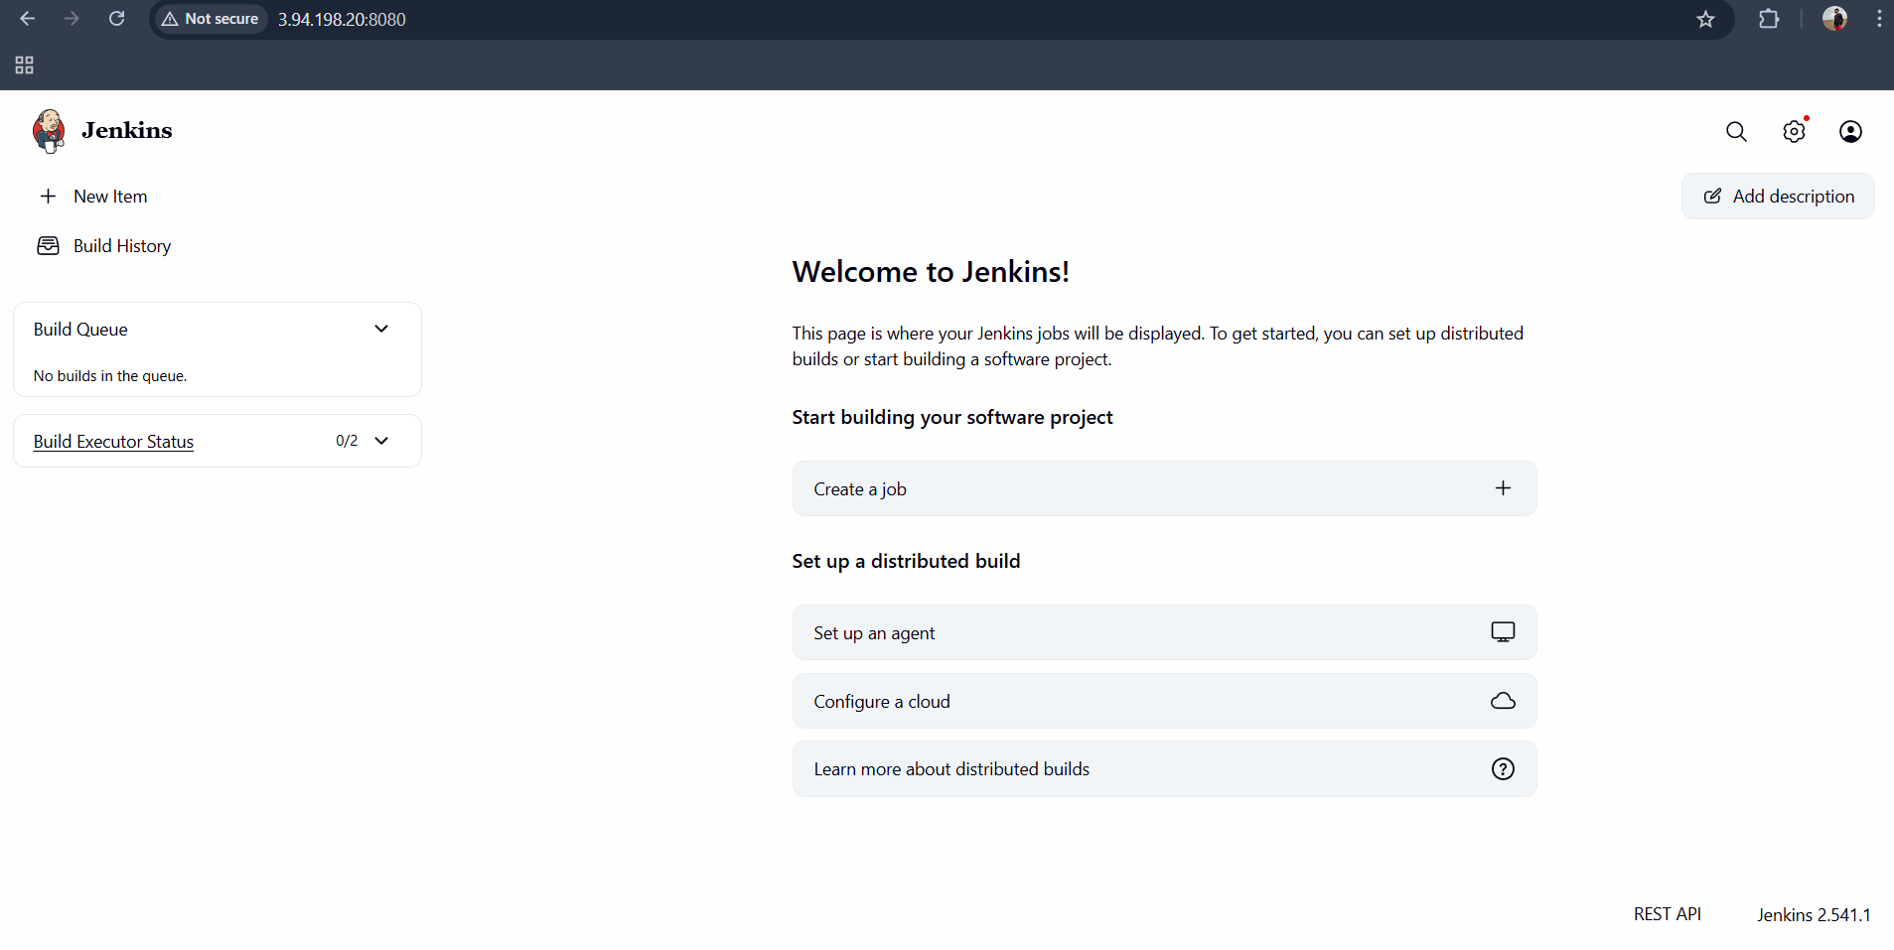

✅ PART 2: Jenkins Job – Build & Push Docker Image to Docker Hub

1️⃣ Install Jenkins Plugins
Manage Jenkins → Plugins
Install:
- Git
- Docker Pipeline

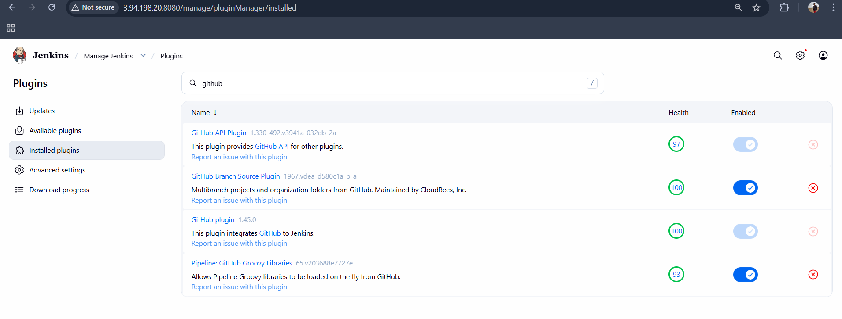
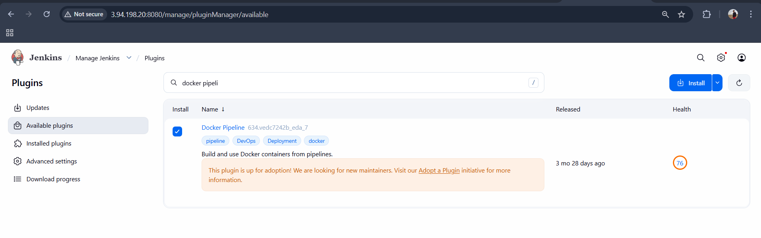

2️⃣ Add Docker Hub Credentials
Manage Jenkins → Credentials → Global → Add Credentials
Field | Value
Kind | Username with password
ID | dockerhub-creds
Username | Shahbazz16
Password | Shaikh@2000

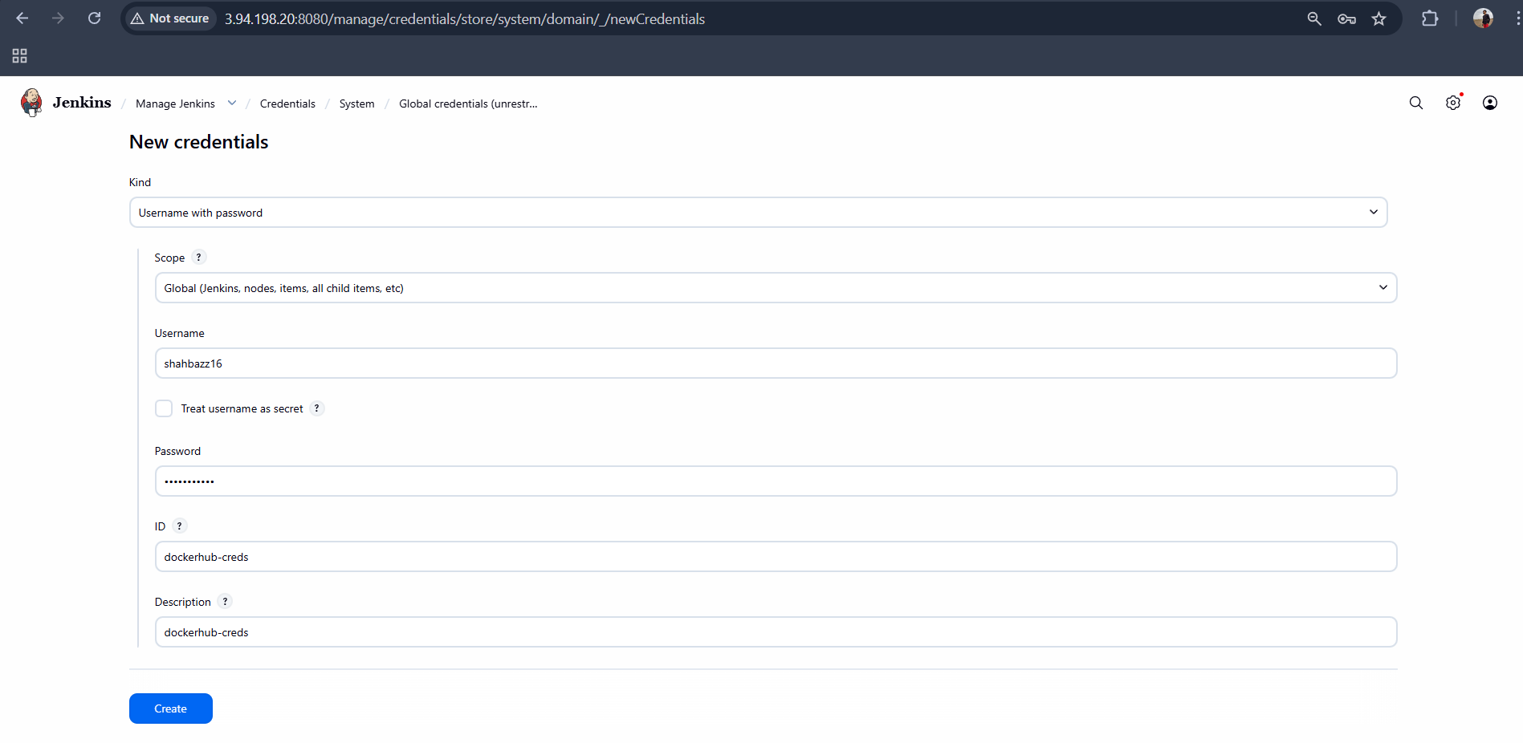

3️⃣ Create Jenkins Pipeline Job
New Item → Pipeline
Job Name:
dockerhub-build-push

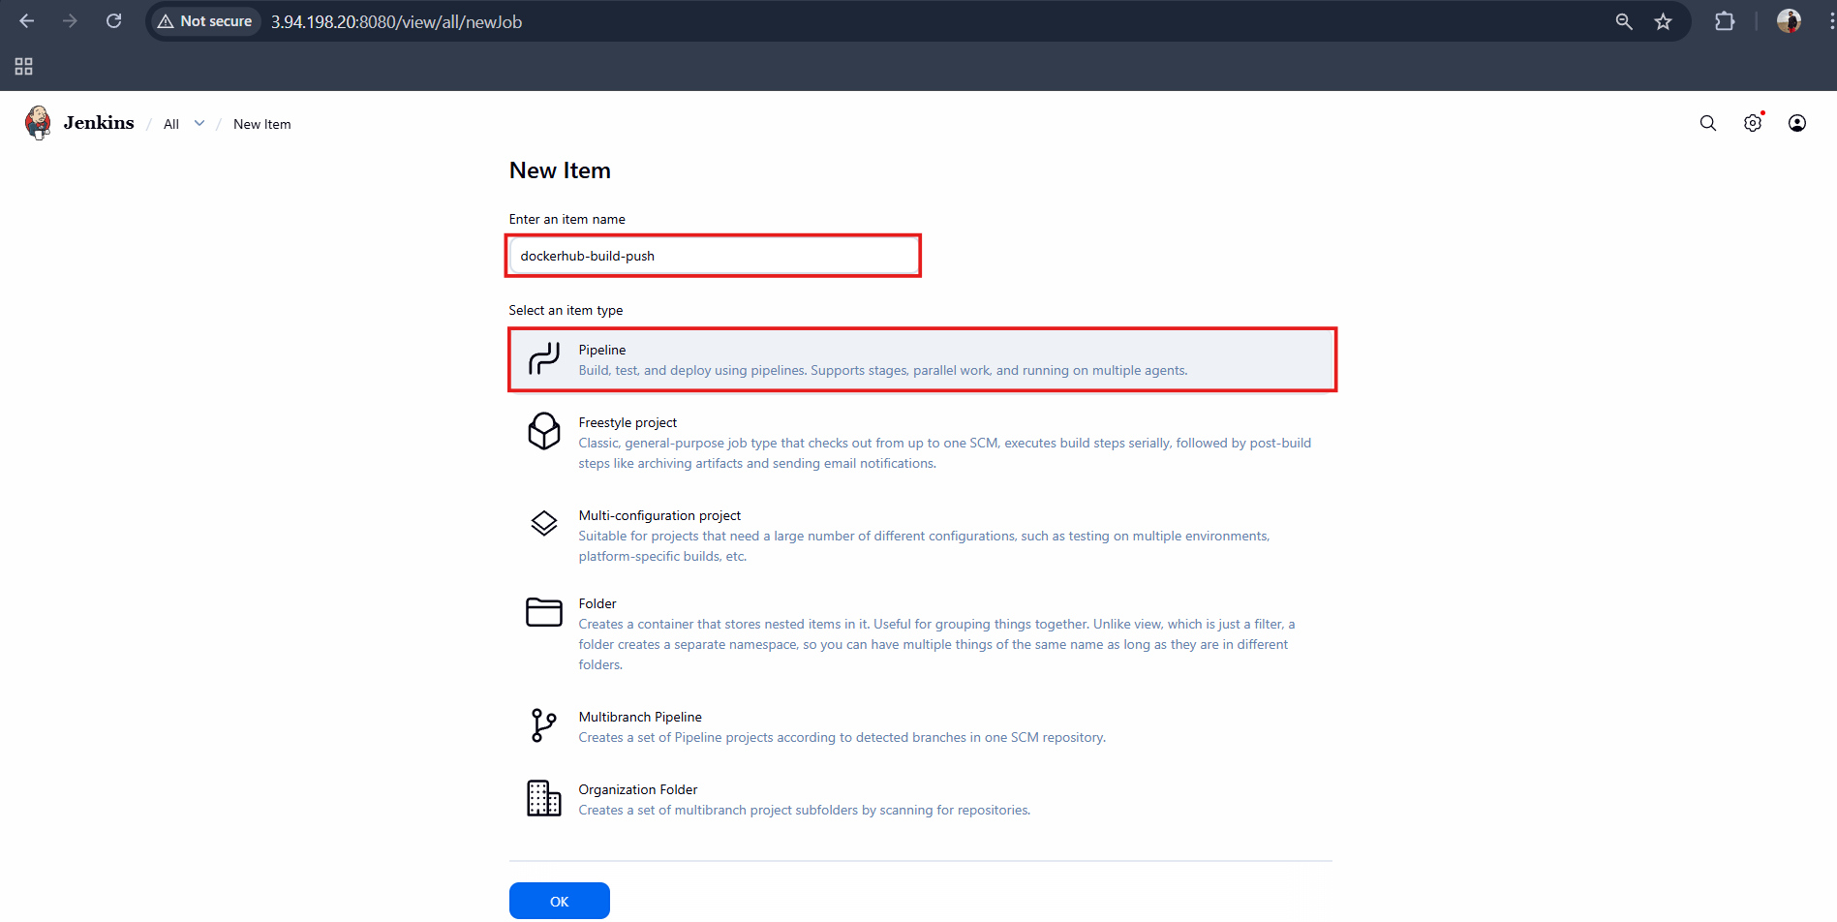

4️⃣ Jenkins Pipeline Script

pipeline {
agent any

environment {
IMAGE_NAME = "python-app"
IMAGE_TAG = "v1"
DOCKERHUB_USER = "shahbazz16"
}

stages {

stage('Clone Repository') {
steps {
git branch: 'main', url: 'https://github.com/shaikhshahbazz/Python-app.git'
}
}

stage('Build Docker Image') {
steps {
sh "docker build -t ${IMAGE_NAME}:${IMAGE_TAG} ."
}
}

stage('Tag Image') {
steps {
sh "docker tag ${IMAGE_NAME}:${IMAGE_TAG} ${DOCKERHUB_USER}/${IMAGE_NAME}:${IMAGE_TAG}"
}
}

stage('Push to Docker Hub') {
steps {
withCredentials([usernamePassword(
credentialsId: 'dockerhub-creds',
usernameVariable: 'DOCKER_USER',
passwordVariable: 'DOCKER_PASS'
)]) {
sh """
echo \$DOCKER_PASS | docker login -u \$DOCKER_USER --password-stdin
docker push ${DOCKERHUB_USER}/${IMAGE_NAME}:${IMAGE_TAG}
"""
}
}
}
}
}

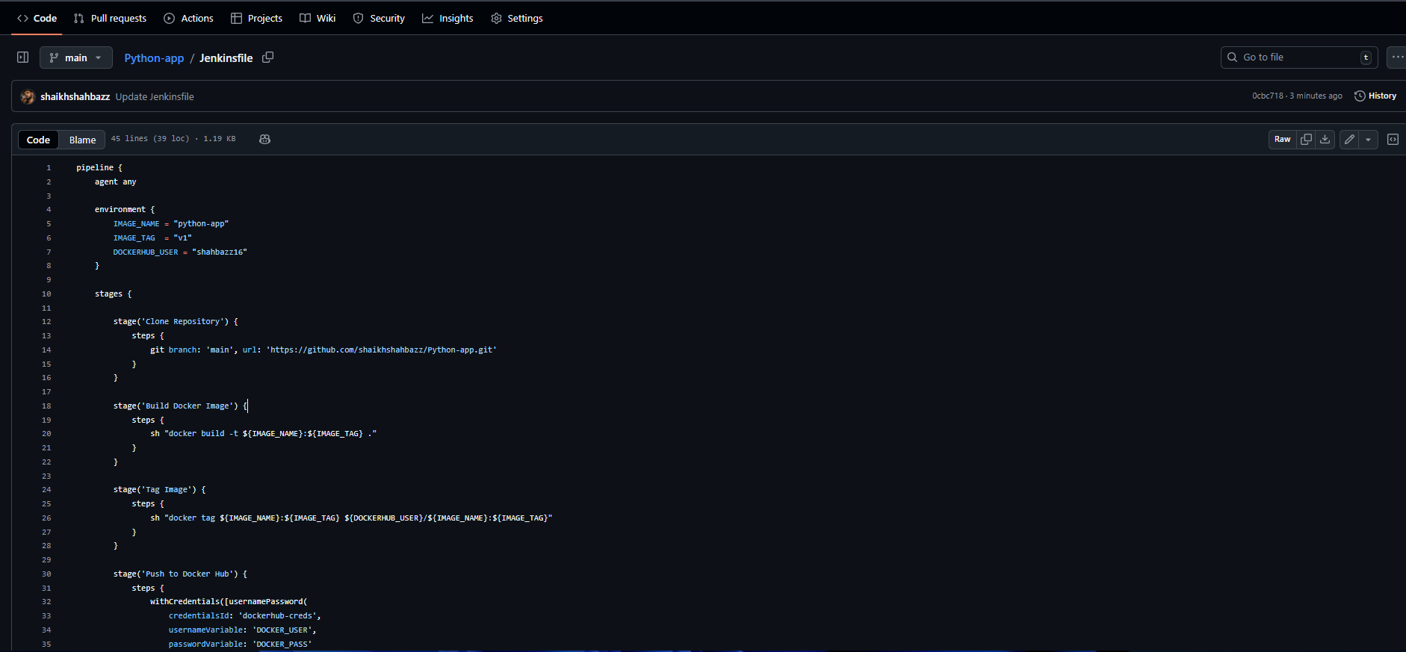

Click Save → Build Now

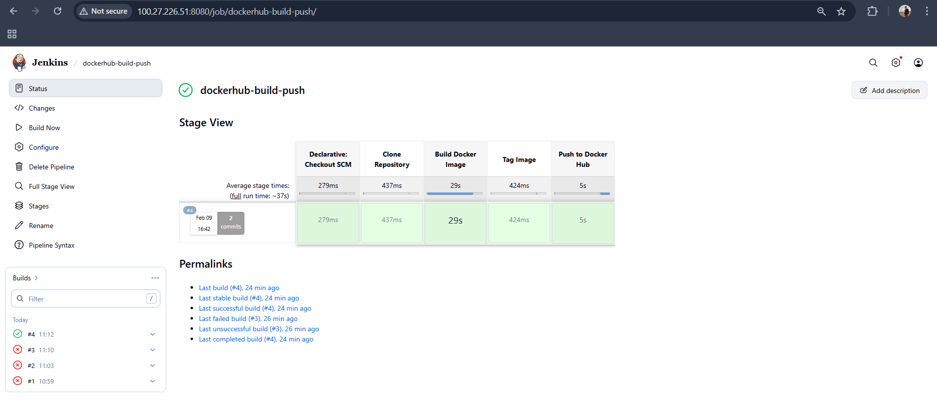

Validation: Check in your dockerhub account
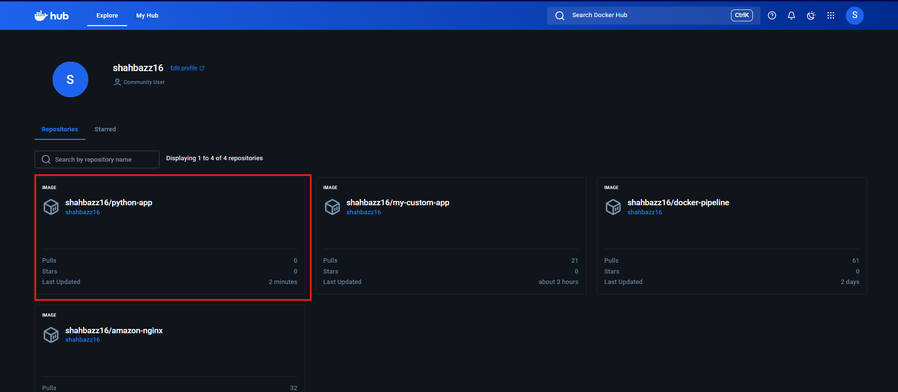

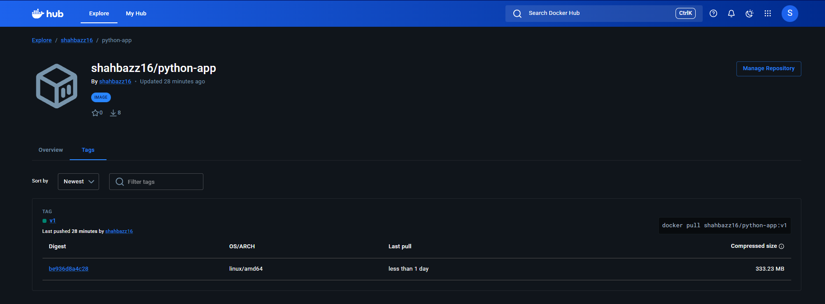

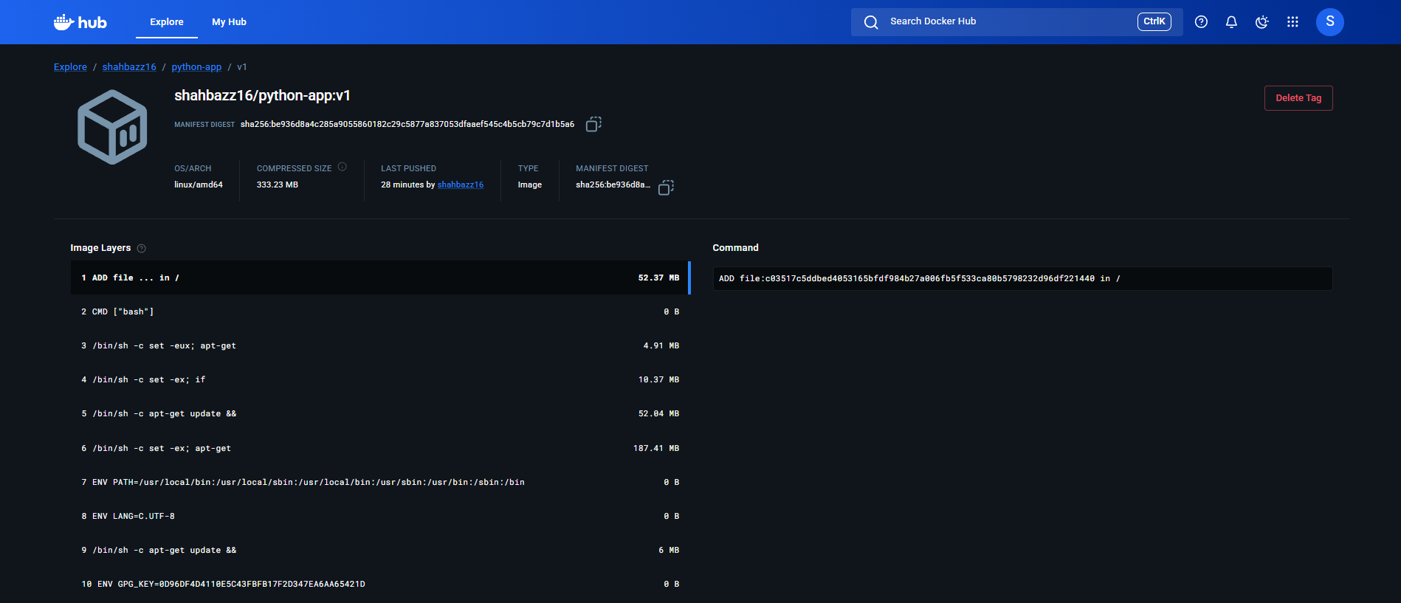

- Source: https://github.com/betawins/Python-app.git
Source Codes: https://github.com/betawins/docker-tasks.git
a. From the frontend source code, write a Dockerfile, build a Docker image, run it, and push that image to your Docker registry.
a) Frontend Source Code
Repo: https://github.com/betawins/docker-tasks.git

Step 1️⃣ Go to frontend directory
git clone https://github.com/betawins/docker-tasks.git
cd docker-tasks/frontend

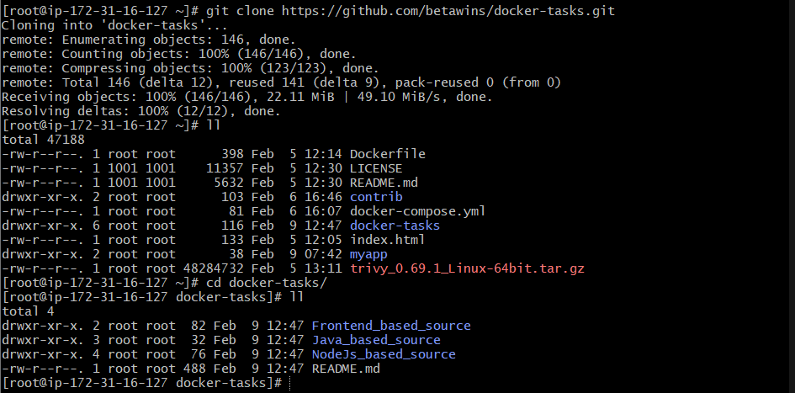
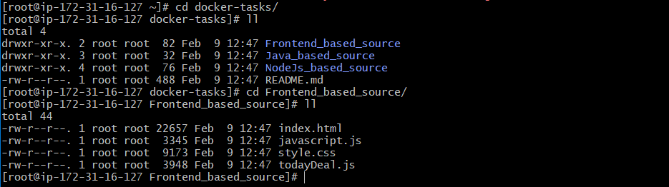

Step 2️⃣ Create Dockerfile

#1. Base module as nginx:latest
FROM nginx:latest

#2. Maintainer your name
LABEL maintainer="shahbazz"

#3. remove default content
RUN rm -rf /usr/share/nginx/html/*

#4. copy one index.html file to image
COPY index.html /usr/share/nginx/html/index.html

#5. Expose on port 80
EXPOSE 80

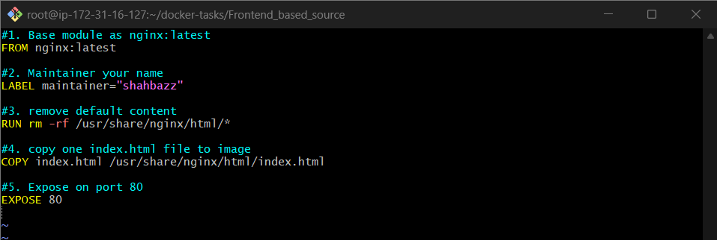

Step 3️⃣ Build Docker Image
docker build -t shahbazz16/frontend-app .

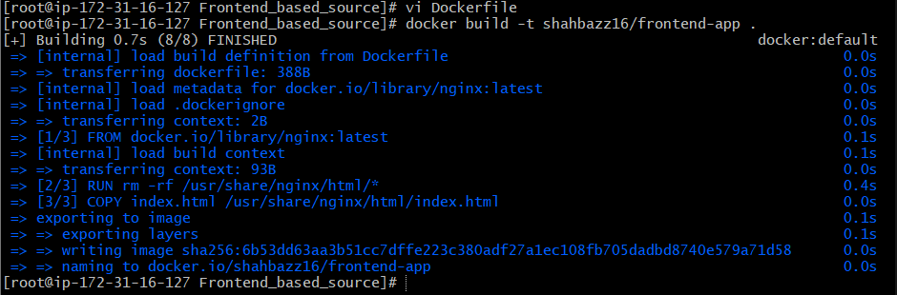

Step 4️⃣ Run Docker Container
docker run -d -p 8080:80 shahbazz16/frontend-app

Step 5️⃣ Push Image to Docker Hub
docker login
docker push shahbazz16/frontend-app
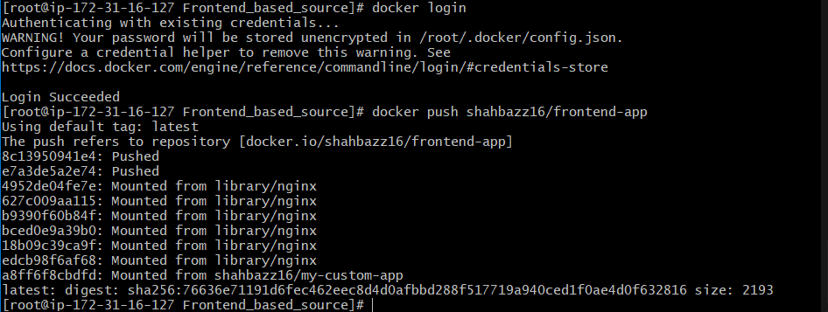

Validation:
In Docker hub account
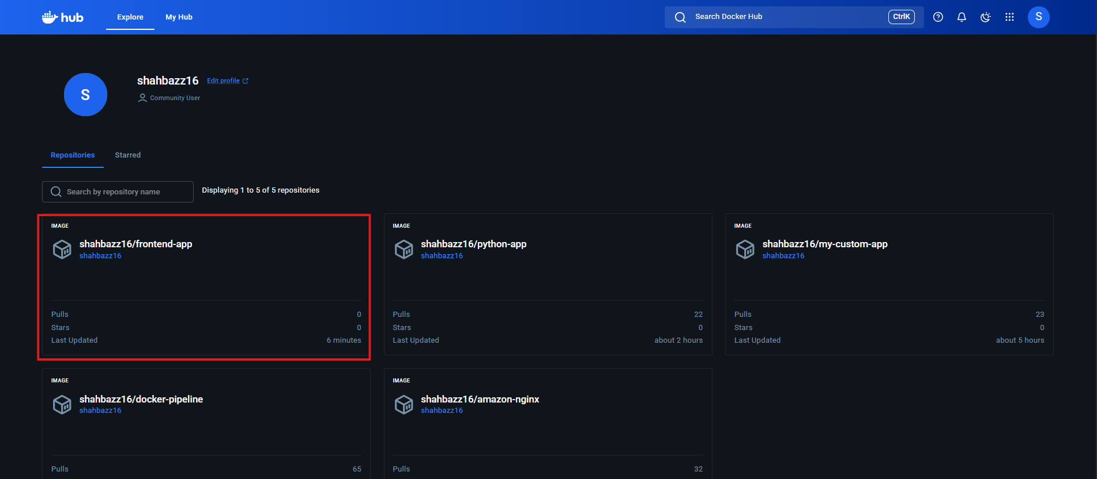

In browser <public-ip> : 8080
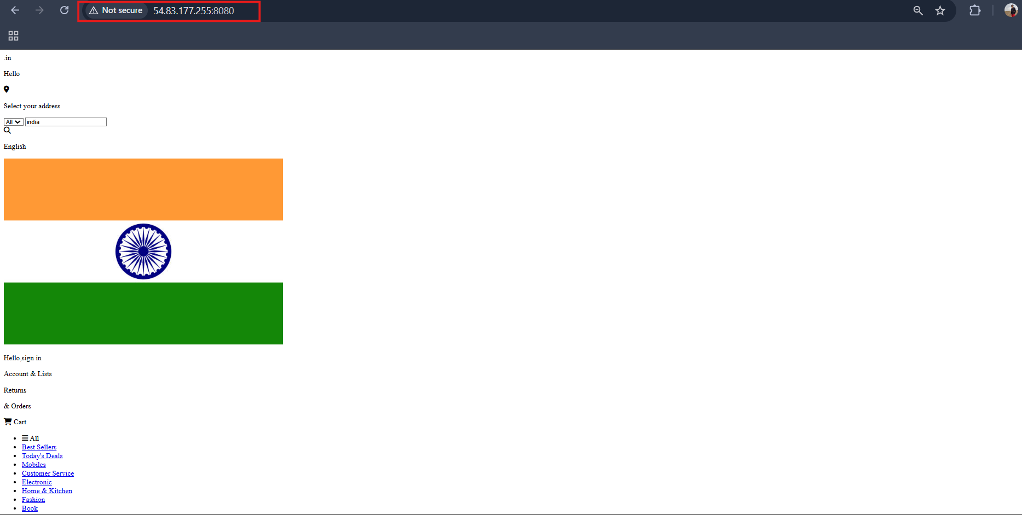
b. From the Java-based source code, write a Dockerfile, build, run, and push the image to the Docker registry.

b) Java-Based Application – Dockerfile, Build, Run & Push

✅ Step 1: Clone the Repository
git clone https://github.com/betawins/docker-tasks.git
cd docker-tasks/java-app
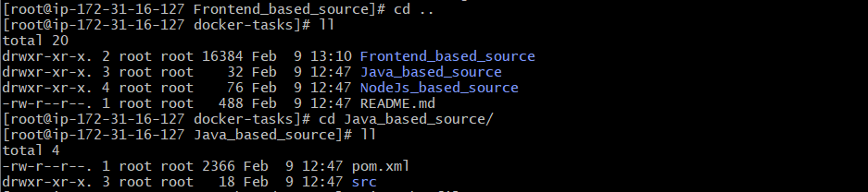
✅ Step 2: Build the Java Application (Create JAR)
Make sure Maven is installed.
mvn clean package
After this, a JAR file will be created in:
target/

✅ Step 3: Create Dockerfile
Create a file named Dockerfile inside java-app directory.
FROM maven:3.9.6-eclipse-temurin-17 AS build

WORKDIR /app
COPY . .
RUN mvn clean package -DskipTests

FROM eclipse-temurin:17-jdk-alpine
WORKDIR /app
COPY --from=build /app/target/*.jar app.jar

EXPOSE 8080
CMD ["java", "-jar", "app.jar"]

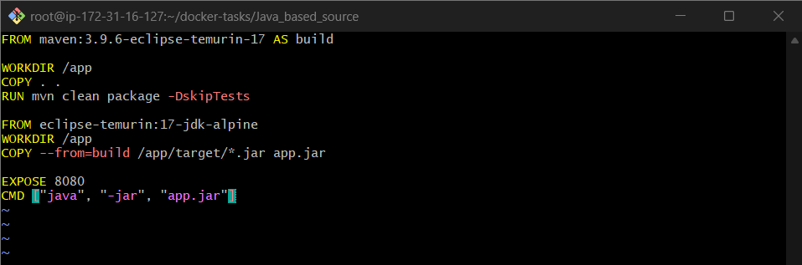

✅ Step 4: Build Docker Image
docker build -t shahbazz16/java-app .
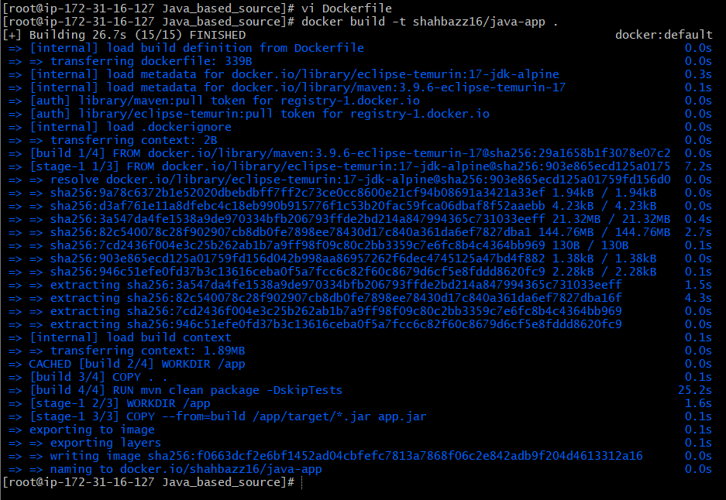

✅ Step 5: Run Docker Container
docker run -d -p 8081:8080 shahbazz16/java-app

Verify
docker ps
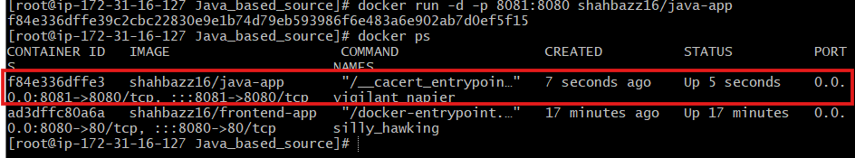
Open in browser:
http://<EC2-IP>:8081
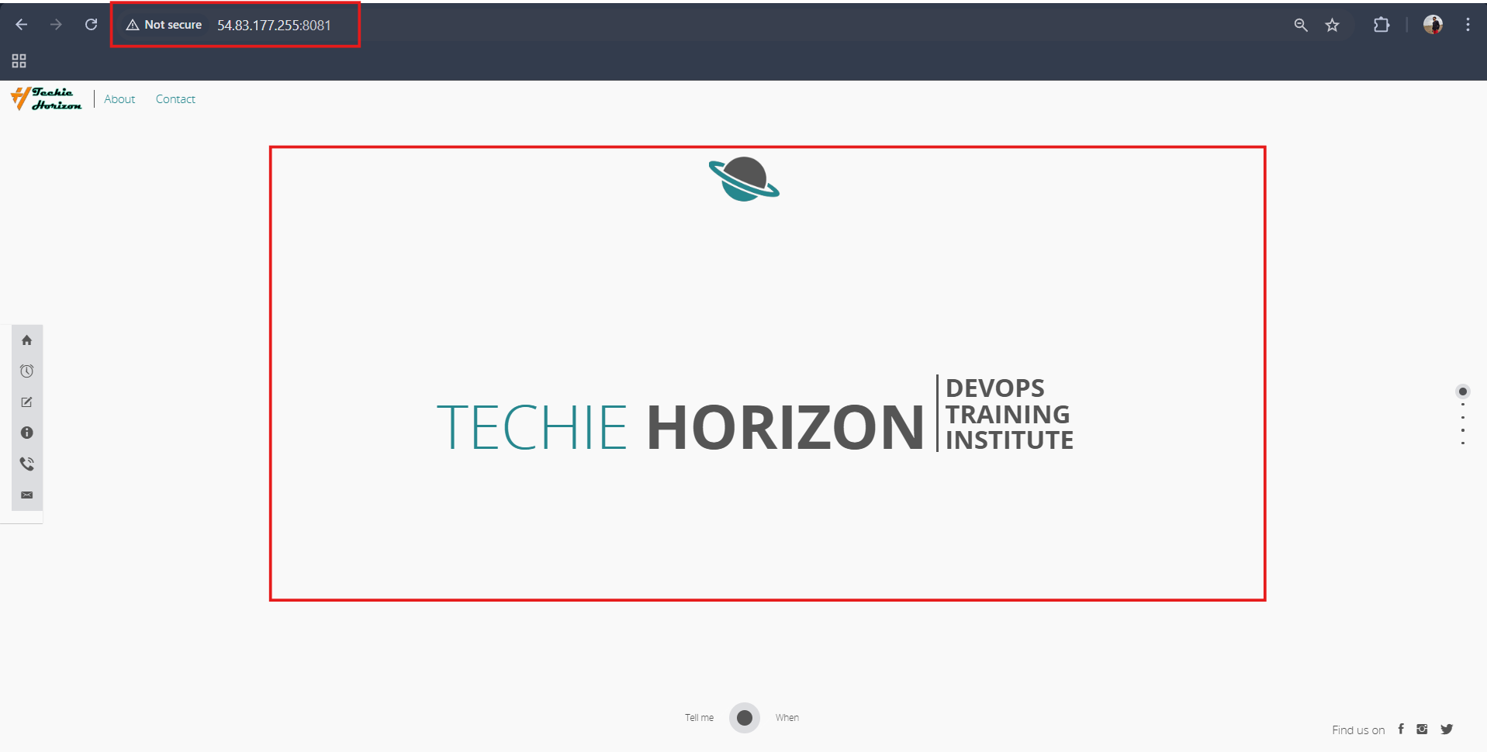
✅ Step 6: Login to Docker Registry
docker login
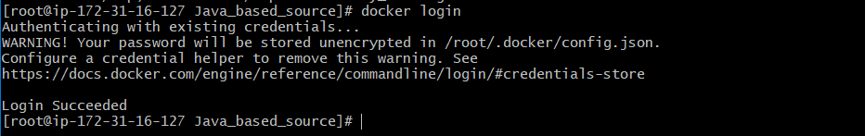
✅ Step 7: Push Image to Docker Hub
docker push shahbazz16/java-app
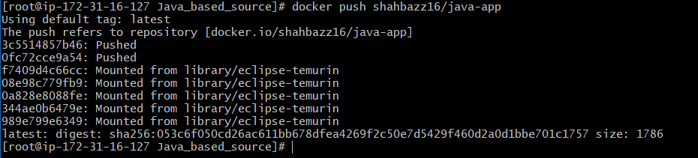

Validation:
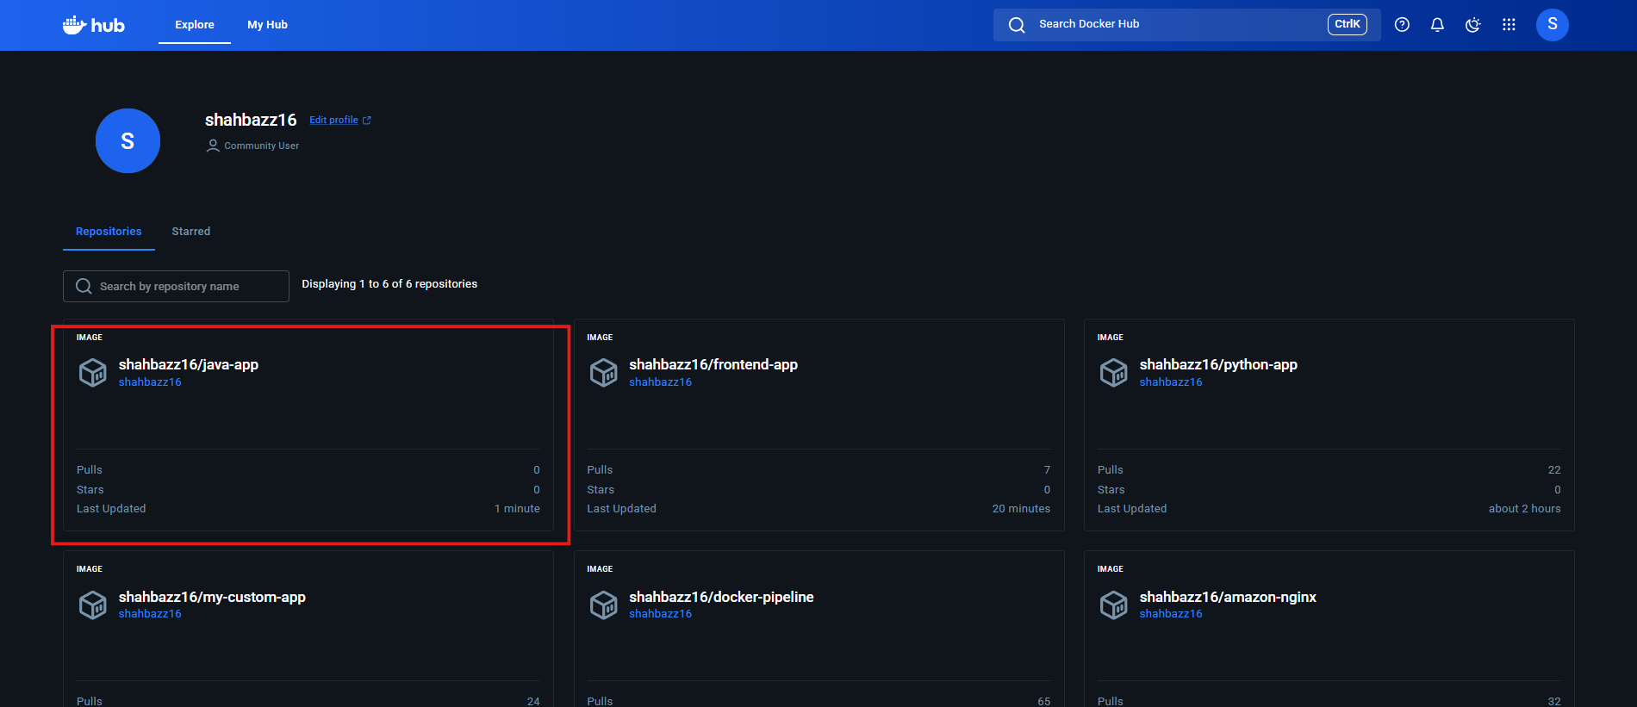

c. From the Node.js-based source code, write a Dockerfile, build with tag v1, run, and push it to the Docker registry.
✅ Step 1: Clone the Repository
git clone https://github.com/betawins/docker-tasks.git
cd docker-tasks/node-app
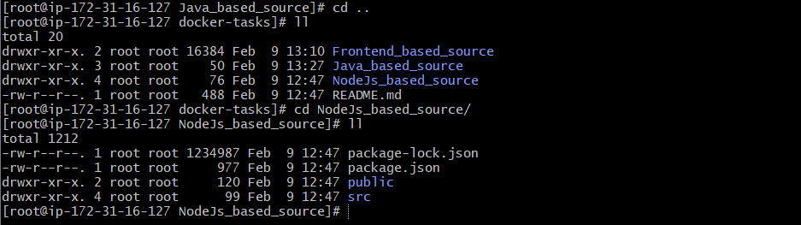
✅ Step 2: Create Dockerfile
Create a file named Dockerfile inside the node-app directory.
FROM node:18-alpine

# create app directory
WORKDIR /app

# copy dependency files first (cache optimization)
COPY package*.json ./

# install dependencies
RUN npm install

# copy remaining source code
COPY . .

EXPOSE 3000

CMD ["npm", "start"]
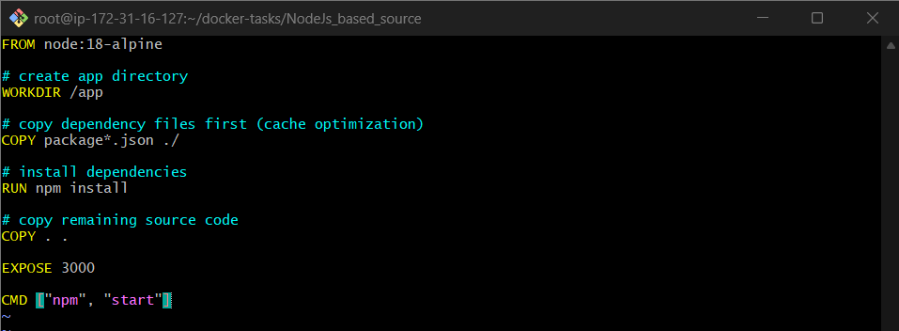

✅ Step 3: Build Docker Image with Tag v1
docker build -t shahbazz16/node-app:v1 .
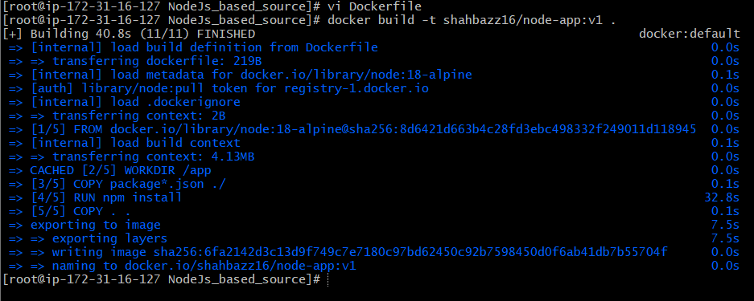

✅ Step 4: Run Docker Container
docker run -d -p 3000:3000 shahbazz16/node-app:v1
Verify Container
docker ps

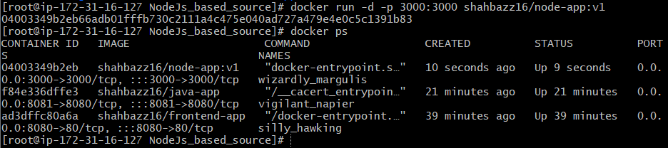

Access application:
http://<EC2-IP>:3000
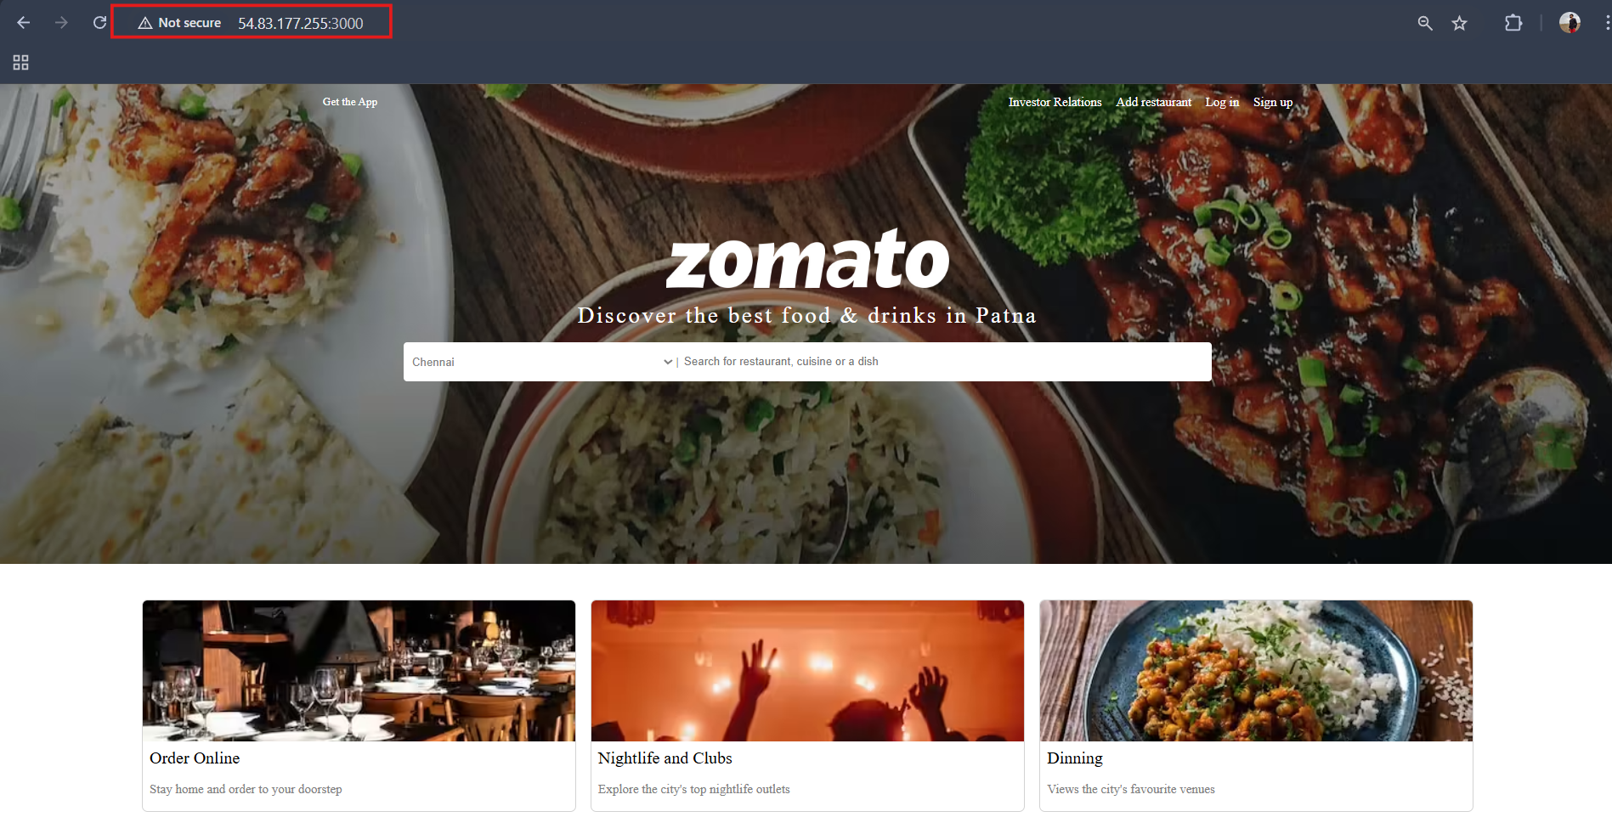
✅ Step 5: Login to Docker Registry
docker login
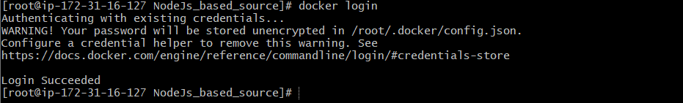
✅ Step 6: Push Image to Docker Hub
docker push shahbazz16/node-app:v1
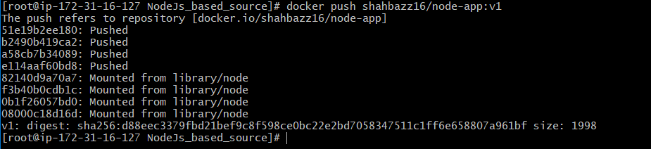

Validation:
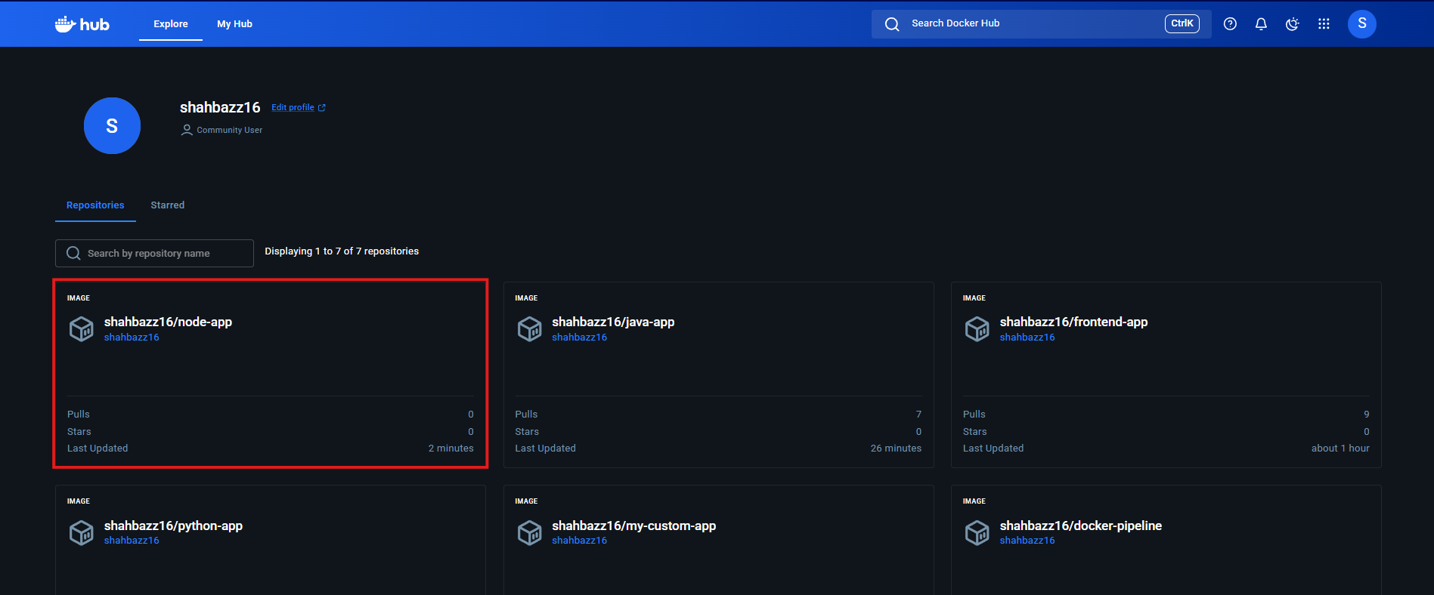

d. Write a docker-compose file to set up WordPress with a MySQL database.
d) Docker Compose – WordPress with MySQL

✅ Step 1: Create Project Directory
mkdir wordpress-docker
cd wordpress-docker

✅ Step 2: Create docker-compose.yml
version: "3.8"

services:
mysql:
image: mysql:5.7
container_name: mysql_db
restart: always
environment:
MYSQL_ROOT_PASSWORD: root123
MYSQL_DATABASE: wordpress
MYSQL_USER: wpuser
MYSQL_PASSWORD: wp123
volumes:
- mysql_data:/var/lib/mysql

wordpress:
image: wordpress:latest
container_name: wordpress_app
restart: always
ports:
- "8080:80"
environment:
WORDPRESS_DB_HOST: mysql:3306
WORDPRESS_DB_USER: wpuser
WORDPRESS_DB_PASSWORD: wp123
WORDPRESS_DB_NAME: wordpress
depends_on:
- mysql

volumes:
mysql_data:

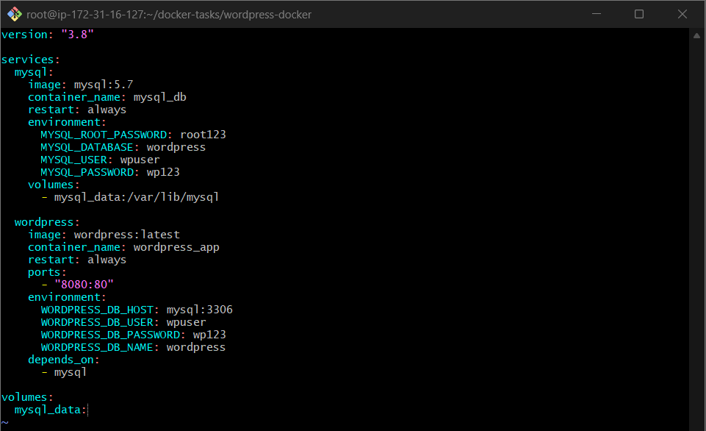

✅ Step 3: Start WordPress & MySQL Containers
docker-compose up -d

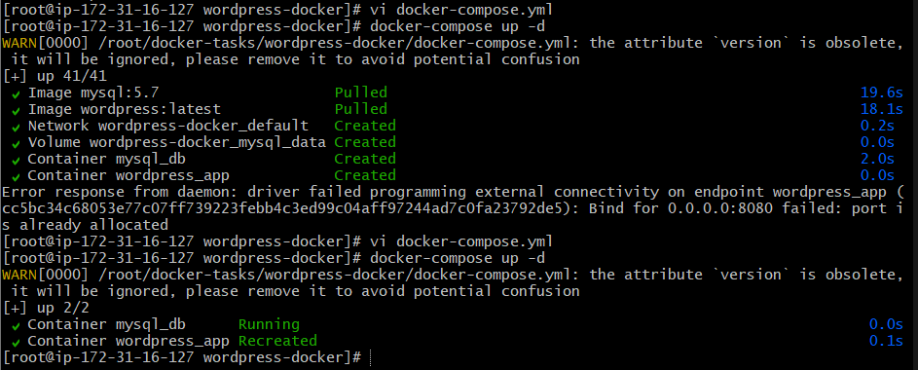

✅ Step 4: Verify Running Containers
docker ps
You should see:
- wordpress-app
- wordpress-db
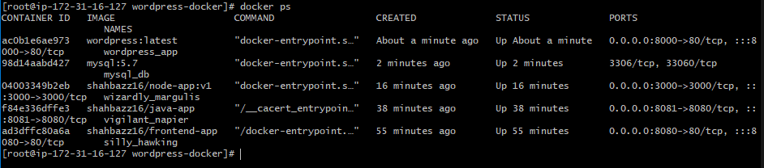

✅ Step 5: Access WordPress in Browser
http://<EC2-IP>:8080
Follow the WordPress installation steps on the browser.

